**Information required from next interview**

Would the admin/manager be able to make modifications to the database on the app as well or just on the website?

What does the current order process look like(More specific) ?

* Clarify if the Received by and the member receiving is in fact the same person.
* Process of filling out the handover sheet

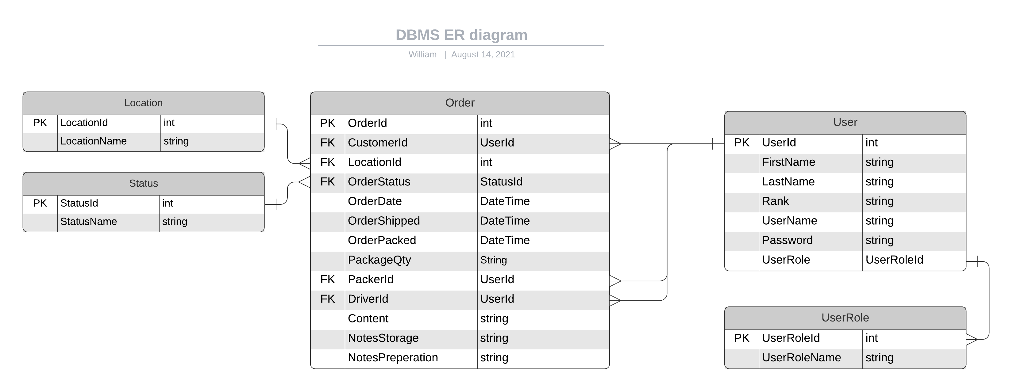

(show database table) image attached

Here’s what we have. Is there any other relevant or important required information needed to be added?

Currently we have designed the application to allow the user once logged in to change their roles depending on their duties.

Will staff be able change roles from a driver / packer?

Will the application be installed on one device for each location or will each user have their own device with the application installed in it?

What will the device specifications be like, will it be IOS/Android, Win10/Mac etc etc?

Printing orders or just the qr code:

Do you want the order form to be printable and/or just setup to print the qrcode?

Authentication

How does one log into a military networked system, login via email/phone number/id/name etc etc.?

Confirm , How would you like to sign health form?